EXPERIMENT-17
17. A healthcare expert system assists doctors by identifying diseases from patient symptoms. Develop a Medical Expert System. Infer diseases using rule-based reasoning.

PROGRAM:
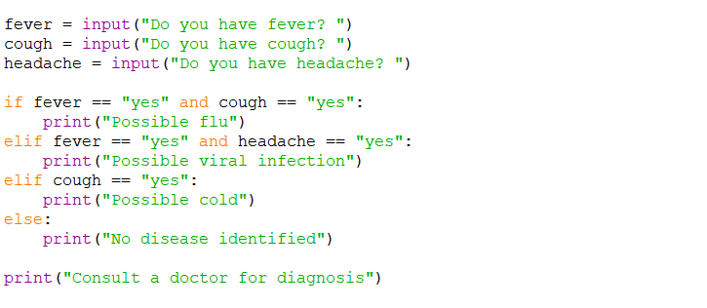

OUTPUT:


